Details and Dialog

# Program 1:

<!DOCTYPE html>

<html lang="en">

<head>

    <meta charset="UTF-8">

    <meta name="viewport" content="width=device-width, initial-scale=1.0">

    <title>Details and Summary Example</title>

    <style>

        details {

            margin: 20px 0;

            padding: 10px;

            border: 1px solid #ddd;

            background-color: #f4f4f4;

        }

        summary {

            font-weight: bold;

            cursor: pointer;

        }

    </style>

</head>

<body>

    <details>

        <summary>More info</summary>

        <p>Here is the detailed information.</p>

    </details>

</body>

</html>

OutPut : 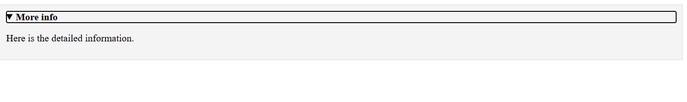

# Program 2 :

<!DOCTYPE html>

<html lang="en">

<head>

    <meta charset="UTF-8">

    <meta name="viewport" content="width=device-width, initial-scale=1.0">

    <title>Dialog Example</title>

    <style>

        dialog {

            padding: 20px;

            border: 1px solid #ddd;

        }

    </style>

</head>

<body>

    <dialog id="myDialog">

        <p>This is a dialog box</p>

        <button onclick="document.getElementById('myDialog').close()">Close</button>

    </dialog>

    <button onclick="document.getElementById('myDialog').showModal()">Open Dialog</button>

</body>

</html>

# OutPut :

